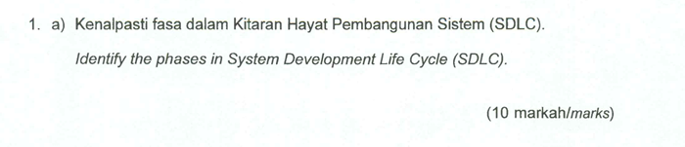

1. Planning
   * Plan the objectives, scopes of the system’s project.
   * Gives out role for each person in the team
2. Analysis
   * Gather all the information about the requirement needed
   * Test the feasibility of the project
   * Make a report to be presented for gathering sponsors and investors
3. Design
   * Early prototype of the project
   * Include the DFD,FDD, Case Diagram, Context Diagram
4. Implementation
   * Developing the systems and integrate the necessary components
   * Run initial product testing
5. Maintenance
   * Documentation needed to maintain the system and update it
   * Fix bugs, update features, and ensure system’s performance

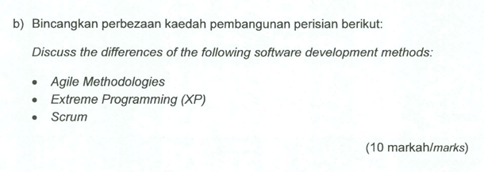

|  |  |  |
| --- | --- | --- |
| **Agile methodologies** | **Extreme Programming** | **Scrum** |
| Iterative and incremental, focusing on delivering small piece of product | Frequent releases with short iteration | Divided into sprints for each features |
| For project with changing requirement where flexibility is crucial | For smaller teams working on a highly technical projects | Effective for teams working on complex project with clear timeline and deliverable |
| Continuous feedback from customer | Customer involvement during each releases | Customer provide input during sprint reviews and planning |

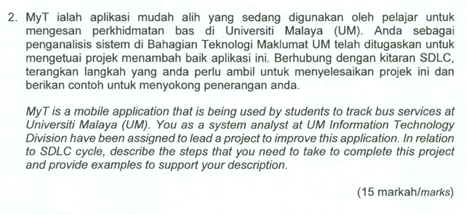

1. Planning
   * After identifying the project, as a system’s analyst I will create a Baseline Project Report
   * In which I will conduct the feasibility assessment and determining the project cost
   * After that I will distribute the necessary role to each team’s member
2. Analysis
   * Gathering requirement for the project. For that I will conduct a group interview and individual interview for the UM students
   * After that I will create a context diagram and data flow diagram for the system
   * This will allow the team to structure the requirement into a diagram for easy understanding.
3. Design
   * After that I will create the Use Case Diagram and Activity Diagram for the system
   * This step is necessary so that it will be easier for the Implementation phase later as it shows all the end users for the system
   * I also will design the User Interface neatly to make it user-friendly for all people that will be using the system
4. Implementation
   * Start to code the systems
   * Run a testing module for the system
   * For example, I will run a code walkthrough, where professionals will be reviewing the code for each module. This will allow us to detect any improvement can be made to the code
5. Maintenance
   * I will be maintaining the system performance by giving out updates
   * I also will document all the process before to allow for an easier maintaining process for future reference

